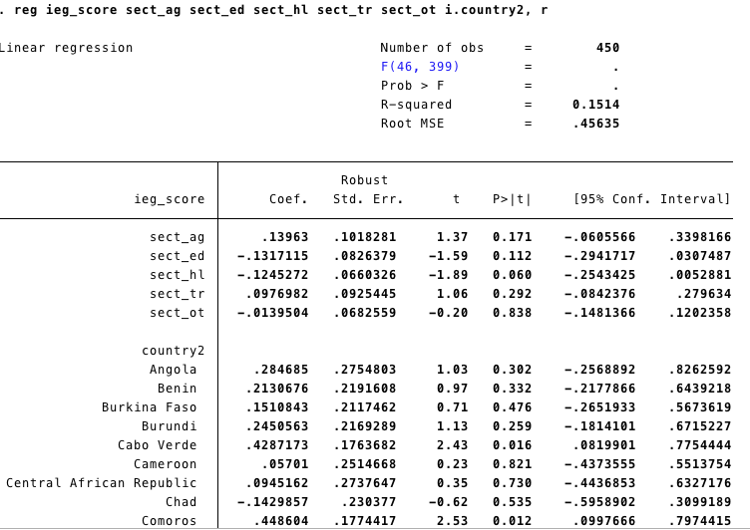

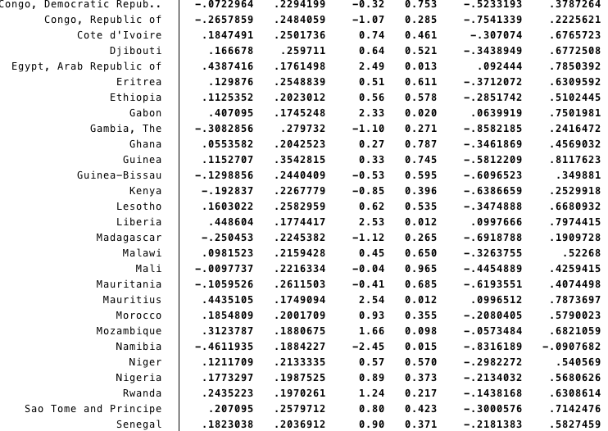

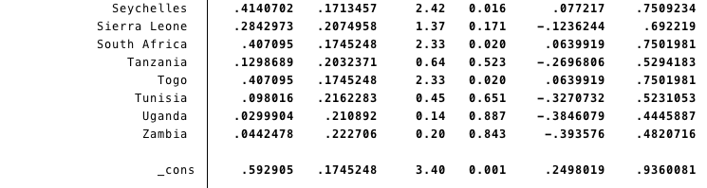

Variables:

ieg_score: 0, 1 – 1 = satisfactory and above

sect_ag: agriculture, fishing, and forestry

sect_ed: education

sect_hl: health and other social services

sect_tr: transportation

sect_ot: all other sectors

Left out category:

sect_pa: public administration, law, and justice (largest category)

Left out country:

Algeria